Tips for Testing CORBA Applications with LoadRunner
This article was written by Stuart Moncrieff. Please visit http://www.myloadtest.com/loadrunner-tips-for-corba for the latest version.

Background
I recently finished my first CORBA project using LoadRunner 8.0, and this is a quick brain-dump of some of my impressions. I found it hard to track down any people who had worked with the LoadRunner CORBA protocol before, so these notes are largely comprised of information that I wish I had known before I started.

If you want to do performance testing of a Java client-server application using CORBA, LoadRunner seems to be the only viable option. CORBA is not supported by Rational and, while Compuware’s QALoad technically supports CORBA, it forces you to work at the Windows sockets level. Note that as the LoadRunner CORBA recording engine hooks into classes as they are loaded into the JVM, it is not able to record non-Java applications which use CORBA.

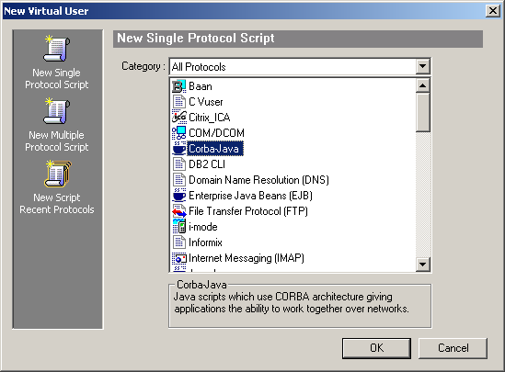

How much Java do you need to know?
LoadRunner CORBA scripts must be written in Java. The level of Java knowledge required is significantly higher than the level of understanding of C required for scripting Web Vusers.

In order to work independently, you should be able to navigate through Javadoc pages and be comfortable with concepts from sections 1, 2, 4, 5, and 6 from the Sun Certified Programmer for Java 2 Platform 1.4 [link: http://au.sun.com/training/catalog/courses/CX-310-035.xml] certification.

If the project has not generated Javadocs for their projects, you will need to be able to navigate through and understand the application source code. Fortunately I did not have to do this as it would have made my job significantly harder.

General information about LoadRunner and CORBA
The recording engine for CORBA is shared between all the Java Vuser types – CORBA, Enterprise Java Beans (EJB), Jacada, Java Vuser (although you don’t record with this type of Vuser), and RMI-Java. It is not possible to create a dual protocol script using any of these protocols. None of these protocols are covered in any Mercury certification exams or training materials.

LoadRunner allows you to define “custom hooks”, which tell the recording engine which classes and method calls to include in the recorded script. This was not necessary for my project, but could be used if the developers or application server vendor decide to extend the CORBA protocol or add non-CORBA calls. Further information can be found in the Support Knowledgebase in Hooking “General” Java API calls with LoadRunner.

Bugs and Workarounds
I experienced several problems when trying to record my application with LoadRunner. Fortunately Mercury has top-notch support, and their R&D team was able to create a patch that fixed my problem.

Several problems were also able to be fixed by the development team from the project I was working on.

LoadRunner experienced errors during recording when trying to access classes that were only located on the server (someone had defined a remote method that used a non-remote class). Copying the jar file to the client and adding it to the recording classpath fixed this problem.

LoadRunner also seemed to be trying to query private member variables during recording. Rather than change the access modifiers for all private member variables in the application, the java.policy file was modified to disable this part of the security model.

grant {
permission java.lang.reflect.ReflectPermission "suppressAccessChecks";
};

A LoadRunner class file was decompiled (using Jad [link: http://www.kpdus.com/jad.html]), and modified to call setAccessible(true) before getDeclaredFields() was called, fixing the problem.

If the recording option “Unfolded Serialized Objects” is enabled and the “Limit Object Size (byte)” property is set to a large number, you may get a “constant string too long” error when compiling your script.

C:\Scripts\string_too_long\Actions.java:1831: constant string too long
_string4 = "com.myloadtest.loadrunner.corbaexample.StringTooLongClass __CURRENT_OBJECT = {" +
1 error

This is a limitation of the Sun Java compiler. The work-around is to break the string up into smaller chunks using the += operator.

Some test cases where a large number of search results were returned to the client caused a stack overflow error at runtime. The work-around for this was to increase the default stack size, using the –Xss option in the “Additional VM Parameters” runtime setting.

Some unfolded serialised objects that had been parameterised also caused stack overflow errors (while compiling). The work-around for this was to separate the parameterised line from the original string and then concatenate the strings using the += operator.

Recording
The application that I was working with was invoked by running a small exe file which displayed a splash screen, and than ran a batch file to start the application. The batch file contained all the command line parameters and classpath information that was necessary to run the application. My first step was to add this information to the Java Environment Settings under Recording Options. Note that jar files must be added individually to the classpath, rather than just specifying their directory.

While working through my LoadRunner recording problems with Mercury R&D, a lot of debugging information was being written to stdout by LoadRunner and the application. Unfortunately, the cmd window can only store the last 9999 lines, so useful information was being lost. A neat workaround for this problem was to pipe the output to a text file.

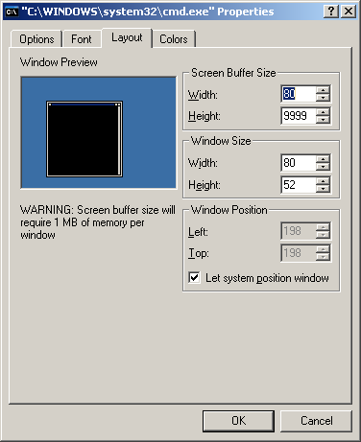

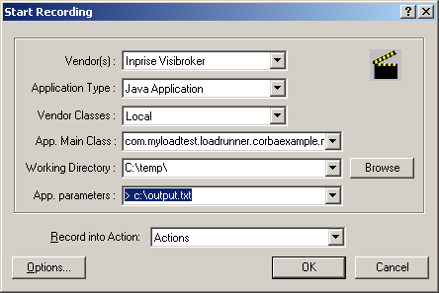

When recording, I think that it is also important to enable Unfold Serialized Objects and increase the Object Size Limit to a large value. The reasons for doing this are discussed in the Correlation section of this document.

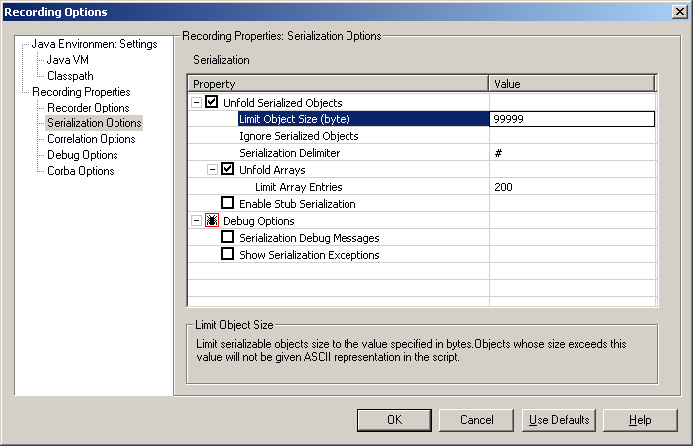

Playback
The LoadRunner Runtime Settings take on the same Java Environment Settings used in the Recording Settings.

To log on as multiple users from the same workstation, each Vuser must be run as a process. I think that this is because the CallbackHandler interface [link: http://java.sun.com/j2se/1.4.2/docs/api/javax/security/auth/callback/CallbackHandler.html] isn’t designed to be aware of threads. My scripts used a customised version of the application’s CallbackHandler class as the developers added a setUserId() method so that each of my virtual users could use a unique username.

Running each virtual user in a process rather than a thread consumes more resources on the load generators. Each of my Vusers used about 26MB of memory (I used an initial heap size of 10MB and an initial stack size of 5MB), so CORBA Vusers are by far the most resource hungry of all the Vuser types I have used so far.

When attempting to run your virtual users from a remote workstation, make sure that the libraries in the classpath are on the workstation or you will get a compilation error.

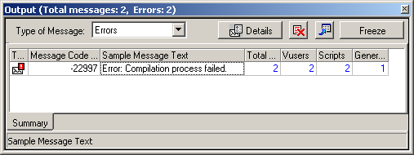

This is obvious when you think about it but this behaviour differs from every other type of Vuser. As far as I know, all other (non-Java) Vuser scripts are totally self-contained, unless you make a call to an external file such as a DLL.

A virtual user will just stop with an error when an exception is thrown by the application and not is caught by your script. This happens even if the “Continue on error” Runtime Setting is enabled. A single exception will register as multiple errors in the LoadRunner Controller – I am not sure why this happens. It may be due to the number of lines that the stack trace occupies.

Scripting
There is no tree view for LoadRunner CORBA Vuser scripts; all work must be done in the script view. A script is composed of an Actions class, with an init, action, and end section. Any object reference variables recorded by LoadRunner are added as fields to the Actions class. This makes it easy to move sections of code between the three methods without having to worry about variable scope.

/*
* LoadRunner Java script. (Build: 739)
*
* Script Description:
*
*/

import lrapi.lr;

public class Actions
{
public int init() {
return 0;
}//end of init

public int action() {
return 0;
}//end of action

public int end() {
return 0;
}//end of end
}

Debugging of scripts would be made easier if Vugen had a feature that made it possible to step through your code and place watches and breakpoints but, as with C-based Vuser types, you can debug your script in a real IDE if you need to.

Sometimes when a runtime exception is thrown and the vuser stops, LoadRunner displays the stacktrace but cannot determine the line number where the exception was thrown. It is possible to work it out from the method that is shown in the stack trace, but (especially when there are multiple calls to the method in the script) it is easier to narrow it down by sprinkling your script with print statements like System.out.println() or lr.output_mesage().

When declaring new object reference variables, LoadRunner sometimes uses the type of the parent class or implemented interface. I think that it only does this because it is reading the method signature, so if a method says that it returns a Collection (which is an interface), then that is what appears in the recorded script. This is only a problem if you need to add a call to a method that is only present in the child class.

SuperClass c = new SubClass();
c.methodFromSubClass(); // This gives a compile time error “cannot resolve symbol”.
((SubClass) c).methodFromSubClass(); // It is necessary to cast, to avoid the compile time error.

It will make your life easier if you change the font used by the Virtual User Generator to something a little smaller (like 8 point) so that you can see more of your code.

Coding style
Some of my recorded scripts were more than 12000 lines long due to the large unfolded serialised objects in the script. To aid navigation around the script, I gave each test step a unique identifier in a comment, so that I could easily jump between steps using Find.

I found that removing the indentation from any code that I added or modified helped to me to quickly scan through a script to find my changes. I found this especially helpful when modifying large unfolded objects.

Any object references that I created always had a fully qualified class name.
Eg.
com.myloadtest.loadrunner.corbaexample.DemoClass dc = new com.myloadtest.loadrunner.corbaexample.DemoClass();
Instead of…
DemoClass dc = new DemoClass();

While this meant that any code I created was more verbose, it made it much easier to cut and paste between scripts without having to worry about having to import the correct packages at the top of the script.

This would be impractical and not very elegant if LoadRunner scripts weren’t designed to be throwaway code.

Correlation
Correlation is by far the most time consuming part of scripting CORBA Vusers. Some correlation is handled for you automatically, but the difficult sections will not be. If anyone has been able to tweak the recording settings so that LoadRunner will correlate everything for them, please let me know.

Unlike other protocols, it is not possible to see any data that is returned by the server (even if you change the Runtime Settings to log the data returned by the server, or change the Recording Settings to “Record Return Value”); this means that you can only guess at what you are getting from the server based on the data that you are sending.

This is the reason I believe that enabling the “Unfold Serialized Objects” Recording Option is so crucial. Unfolding serialised objects means that each object that is sent to the server is shown in your script in a human-readable string format that can be parameterised. If this option is not enabled, objects to be sent to the server are stored in files in a non-readable format, and obviously can't be manipulated as strings.

Here is a simple example of a recorded script from a hypothetical business card manager application, where a user searches for a business card (by the website address on the card), opens the card, modifies the contents and then saves the card.

_string = "com.myloadtest.loadrunner.corbaexample.CardSearchCriteria __CURRENT_OBJECT = {" +
"java.lang.String cardTitle = ##" +
"java.lang.String cardName = ##" +
"java.lang.String cardCompany = ##" +
"java.lang.String cardEmail = ##" +
"java.lang.String cardPhoneNumber = ##" +
"java.lang.String cardURL = #www.myloadtest.com#" +
"}";

_cardsearchcriteria = (com.myloadtest.loadrunner.corbaexample.CardSearchCriteria)lr.deserialize(_string,0); // RMIComponent

_list = _searchservice.searchExecute((com.myloadtest.loadrunner.corbaexample.CardSearchCriteria) _cardsearchcriteria, 200);

_searchservice.getCardFullValue("12357", false);

_string2 = "com.myloadtest.loadrunner.corbaexample.CardFullValue __CURRENT_OBJECT = {" +
"long m_CardId = #12357#" +
"boolean m_IsClient = #false#" +
"java.lang.String m_Title = #Mr.#" +
"java.lang.String m_Name = #Stuart Moncrieff#" +
"java.lang.String m_Company = #MyLoadTest#" +
"java.lang.String m_Email = _NULL_" +
"java.lang.String m_Phonenumber = _NULL_" +
"java.lang.String m_Website = #www.myloadtest.com#" +
"}";

_cardfullvalue = (com.myloadtest.loadrunner.corbaexample.CardFullValue)lr.deserialize(_string2,1); // RMIComponent
_cardservices.save((com.myloadtest.loadrunner.corbaexample.CardFullValue)_cardfullvalue);

You can see that the contents of the cardsearchcritieria object first appears in string form in the script, with the user's search term in one of the object's fields. The real cardsearchcritieria object is then created by making a call to the LoadRunner method lr.deserialize().

The search is executed, and returns a Collection (a List) object containing business card objects that match the search criteria. As there is only one result, the application opens the card in full by calling the getCardFullValue() method with the card Id as the argument. It would be good practice to add code to handle the case where the list is empty (if _list.isEmpty() == true), and where the search returns multiple results.

The argument to the getCardFullValue() will be different for each search term used and is not entered by the user, so this value must be correlated. To get this value, it is necessary to add code to extract the first business card object from the List, extract the card Id from the object, and then use the card Id value in the getCardFullValue() method call.

When the user presses the edit button to allow modification of the card properties, there are no method calls recorded as this activity happens entirely on the client.

The modified business card is recorded in the script as _string2. The string form of the object is converted to a real object with another call to lr.deserialize(). The modified object is then saved. To verify that the script has worked correctly, a check could be added to verify that the save operation returns true.

Obviously the contents of _string2 will be different for each business card, and the values are hard-coded in the recorded version of the script. There are really only three options when it comes to updating these values.

- Extract each field value from the object returned by getCardFullValue() (in the same manner as the card id was extracted from _list), and add the values in string form to _string2.
- Extract each field value from the object returned by getCardFullValue(), and add the values to the _cardfullvalue object using the object's setter methods.
- If the test case only calls for a change to a single property when editing the business card, it seems to be far too much work to have to correlate all the other fields individually. Simply comment out the _string2 step and the lr.deserialize() step, and modify this property in the CardFullValue returned from the getCardFullValue() method call.

In general, the correlation process is as follows.

- Record test case multiple times with different data.
- Use WinDiff to identify values being sent to the server that must be correlated (if you have not enabled "unfold serialized objects", you won't be able to see the content of the objects which are being sent to the server). Obviously ignore values that you have entered through the application's interface; these will be parameterised but not correlated.
- Take an educated guess as to which method returns the value that must be correlated, and assign the value to a variable (if it is not already assigned).
- Confirm your guess by sending the contents of the variable to the Execution Log using System.out.println(). Note that System.out.println() calls the toString() method for the object. If the developers have not overridden this method, you will get something useless like “NameOfClass@hashcode”, in which case you are forced to look at the Javadocs or source code for clues as to whether it may contain the type of value you want. Reading the log should confirm whether you are looking at the correct variable.
Rather than replaying the entire script to see if you have identified the correct method, a return statement can be placed directly after it. Putting the return statement in a conditional block (that evaluates to true every time) will silence any compiler complaints about unreachable code.
- Once you have found the object that contains the value you must correlate, you need to extract the value.
It is possible (although not elegant) to call the toString() method for the object and extract the value using string functions.
However, it is much safer to use the getter method that returns the value you want. Hopefully this can be found in the Javadocs.
If it is not clear what class the object belongs to, you can use the getClass() method that every class inherits from java.lang.Object to determine where you should be looking in the Javadocs. This sometimes happens when a method returns a collection, and the developers are not diligent enough to note in the Javadocs what the collection actually contains. LoadRunner also has a tendency to declare objects using the object’s superclass. This might mean that you are looking in the wrong class when searching for a method to return the value you want.
The value that you wish to extract may be contained within an object that is within the object (etcetera). It will be necessary to create a temporary object reference variable for each layer that you have to drill down to.
- Using the value for correlation is as simple as adding it to the method argument where it is to be used, inserting the value into the string that is the unfolded serialised object, or using the object's setter method to update the value.

It is tempting to try to take a shortcut by guessing which sections must be correlated without going to the effort of recording the business process multiple times with different data and comparing the scripts with WinDiff. It is reasonable to do this with some other protocols, such as HTTP where it is usually obvious what needs to be altered, but it is not good practice to do this with CORBA scripts as they are vastly more difficult and it is not possible to see data returned by the server. Remember that just because the script plays back without error does not mean that it is doing the same thing that a real user does

Rescripting
Allow more time than you usually would for rescripting. LoadRunner CORBA scripts are very sensitive to code changes. You don’t have to just worry about new method calls being added, or the arguments to method calls changing, you also have to worry about any internal changes to objects that are sent to the server.

For example, if one of the developers decides to rename the size field to length in the superclass of MyArrayList, it will not break any of his code because it is only used internally by the object, but it will break your LoadRunner script, because you are, as far as the application is concerned, sending it a corrupt object.

_string2 = "com.myloadtest.loadrunner.corbaexample.MyArrayList __CURRENT_OBJECT = {" +
"super = {" +
"super = {" +
"}" +
"int modCount = #0#" +
"int size = #0#" +
"}" +
"java.lang.Object elementData[] = {" +
"}" +
"}";

Writing to a file
It is often useful for virtual users to write data to a file. Note that the lr.output_message() and lr.log_mesage() methods do not work when logging is disabled or when the “send messages only when an error occurs” runtime setting is selected.

Writing to a file is a little more complicated than in C. Fortunately, this is one of those problems that are solved in 5 seconds with a Google search.

String outputString = "hello world";
String fileName = "c:\\output.txt";

try {
// Open file in "append" mode and write outputString to it.
java.io.BufferedWriter out = new java.io.BufferedWriter(new java.io.FileWriter(fileName, true));
out.write(outputString);
out.newLine();
out.close();
} catch (Exception e) {
// fails silently if an exception occurs.
}

The only thing to be aware of is that this code isn’t technically safe for concurrent use. There is nothing stopping a virtual user from opening the file and writing a string to where it thinks the end of the file is, only for another vuser to have already written something to that position.

With any other language, you would normally prevent concurrency problems by
- Opening the file/obtaining a handle
- Locking the file
- Writing to the file
- Unlocking the file
- Closing the file

In Java, you could put your file writing routine in a synchronised method, but that is only useful for restricting access to a single thread at a time, rather than a process (remember that each vuser must have it’s own process if you are to have multiple logins).

You could either kludge a solution together yourself (like creating a temporary file called filename.lock and not opening another file for writing until the file is deleted), or be pragmatic and not worry about concurrency problems as they will be rare and the data you are writing to the file will probably not be crucial.

If you are lucky enough to be using Java 1.5, you may find something useful in java.util.concurrent.

Transaction timings and transaction status
Unfortunately, the following functions and methods have not been implemented in Java for LoadRunner 8.0 – lr_wasted_time(), lr_get_transaction_status(), lr_get_transaction_wasted_time(), lr.get_transaction_think_time(), lr.get_transaction_duration(). This is a little frustrating if you want to do something like: log all search terms that take longer than 10 seconds to execute, and record the time it takes to return a result.

Fortunately, this sort of problem is easy to solve with the Java API.

// Start time.
java.util.Calendar startTime = java.util.Calendar.getInstance();

// Perform search.
_list = _searchservices.searchExecute(_searchcriteria, 1000);

// Stop time
java.util.Calendar endTime = java.util.Calendar.getInstance();

// If search took longer than 10 seconds, log data used to a file.
long timeTaken = endTime.getTimeInMillis() - startTime.getTimeInMillis();
if (timeTaken > 10000) {
f.writeToFile(_searchcriteria.toString() + "," + timeTaken)
}

All of the timing and transaction status functionality that is missing can be easily kludged together with some custom code. It helps that the only types of errors that your script will generate are either user-defined or the result of exceptions which are unrecoverable anyway. This makes transaction status easy to determine.

Handling immutable Collections
Occasionally you might need to correlate a value using Java method calls on an object that cannot be modified. This may be an object that has private fields and no setter methods, or it may be an object that explicitly does not allow its setter methods to be called.

If you are making a very simple change, it may be possible to do this by just using the LoadRunner correlation functions but, if not, the solution is to create a new object of the same type (or which implements the same interface), copy any necessary properties from the old object, and give it any new properties necessary for the correlation to succeed.

The following is an example of an object which contains an UnmodifiableCollection, which I want to update.

// I want to add an additional Manager to the User object.
UnmodifiableCollection c = _user2.getManagers();

// Create a new Manager object with the desired properties.
Manager newManager = new Manager(1, "Frank", 9);

// As I cannot change the Collection, I must create a new Collection and add the values that I want.
ArrayList a = new ArrayList();
a.add(newManager); // Add the newly created Manager object to the Collection.
a.addAll(c); // Add the rest of the Manager objects to the Collection.

// Add the Collection of Managers back to the User object.
_user2.setManagers(a);

And Finally…
There is very little information available anywhere else for the LoadRunner Java-based protocols. I hope that readers have found that this document provides useful supplementary information to the official Mercury documentation.

Don't forget to visit http://www.myloadtest.com/ for any updates.

