Extracting Errors from the LoadRunner Database

It is easy to view the number and type of errors as they occur during your test from LoadRunner Controller. It is difficult to determine error information with the same level of detail after the test unless the errors are exported to a file before the Controller is closed.

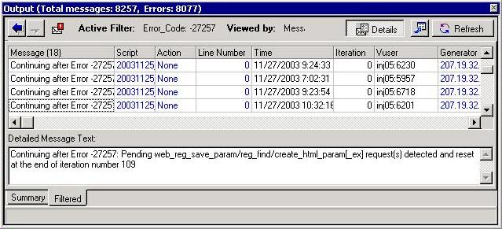

All errors are written to a Microsoft Access file in the results directory (output.mdb). Knowledge Base article #4164 provides an executable that extracts this information in the same format as the LoadRunner 7.2 Controller; and article #4840 shows how to extract all errors types at once with a SQL statement in Access. This article provides SQL statements to recreate all the error views provided by the LoadRunner Controller. It should be useful to people who want detailed error information, who do not want to run an untrusted executable on client machines, and who want the ability to easily modify their queries.

LoadRunner 7.8 includes some queries in output.mdb, but they have no description and do not provide the same views as the Output window in LoadRunner Controller.

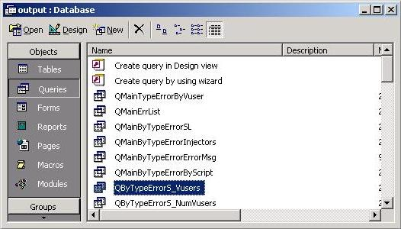

To re-create the Output window with error counts for all error types, use:

SELECT
ErrorSummary.Type,
ErrorSummary.Error_Code,
ErrorSummary.Error_Template,
ErrorSummary.Total_Messages,
ErrorSummary.[#Vusers],
ErrorSummary.[#Scripts],
ErrorSummary.[#Generators]
FROM
ErrorSummary
WHERE
ErrorSummary.Type=2;

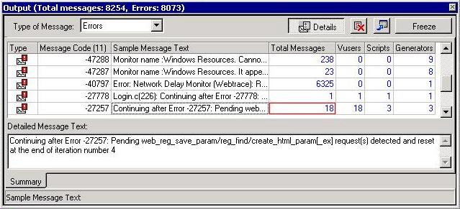

User-defined output and debug messages are also written to the database. To restrict the query to errors only, disregard entries with Type not equal to 2.
To re-create the Output window for a specific error type, use:

SELECT
ErrorMessages.Message_String,
Scripts.Script_Name,
Actions.Action_Name,
Main.Line, Main.Time,
Main.Iteration,
VusersID.Vuser_ID_Name,
Injectors.Injector_Name
FROM
((((Main
INNER JOIN
ErrorMessages
ON
Main.Message_ID = ErrorMessages.Message_ID)
INNER JOIN
Scripts
ON
Main.Script_ID = Scripts.Script_ID)
INNER JOIN
Actions
ON
Main.Action_ID = Actions.Action_ID)
INNER JOIN
VusersID
ON
Main.Vuser_ID = VusersID.Vuser_ID)
INNER JOIN
Injectors
ON Main.Injector_ID = Injectors.Injector_ID
WHERE
Main.Type=2
AND
Main.Error_Code=-17999
ORDER BY
Main.Time;

The Error_Code value should be changed to the code for the desired error.
Note that this is similar to the pre-defined query QmainErrList in the Access database.

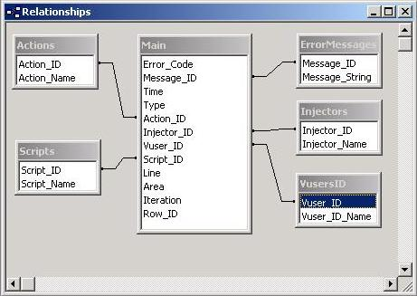

In general, when exporting a particular type of error, the most important fields to extract are Message, Time and Vuser. Modify these SQL scripts as needed.

Stuart Moncrieff, 2003.

